Abstraction program.cs

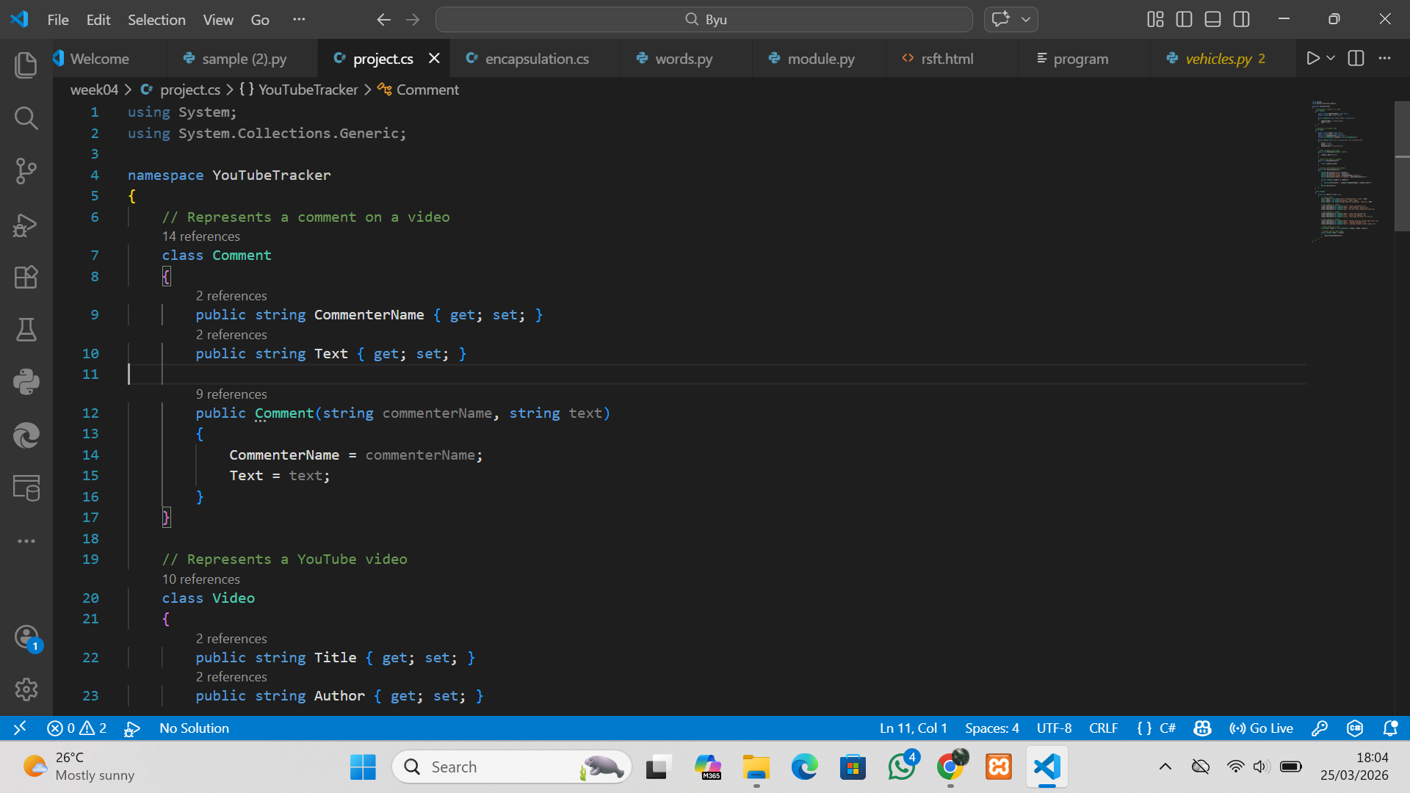

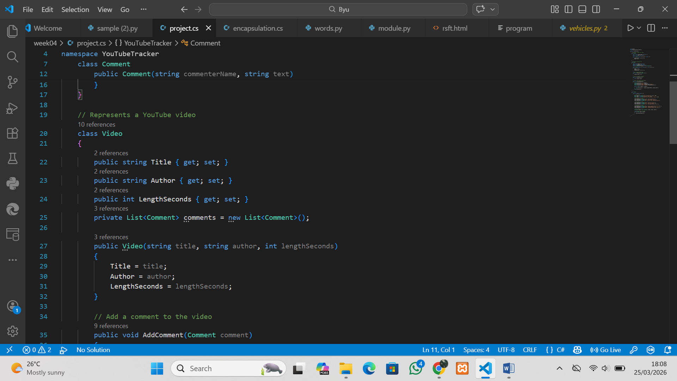

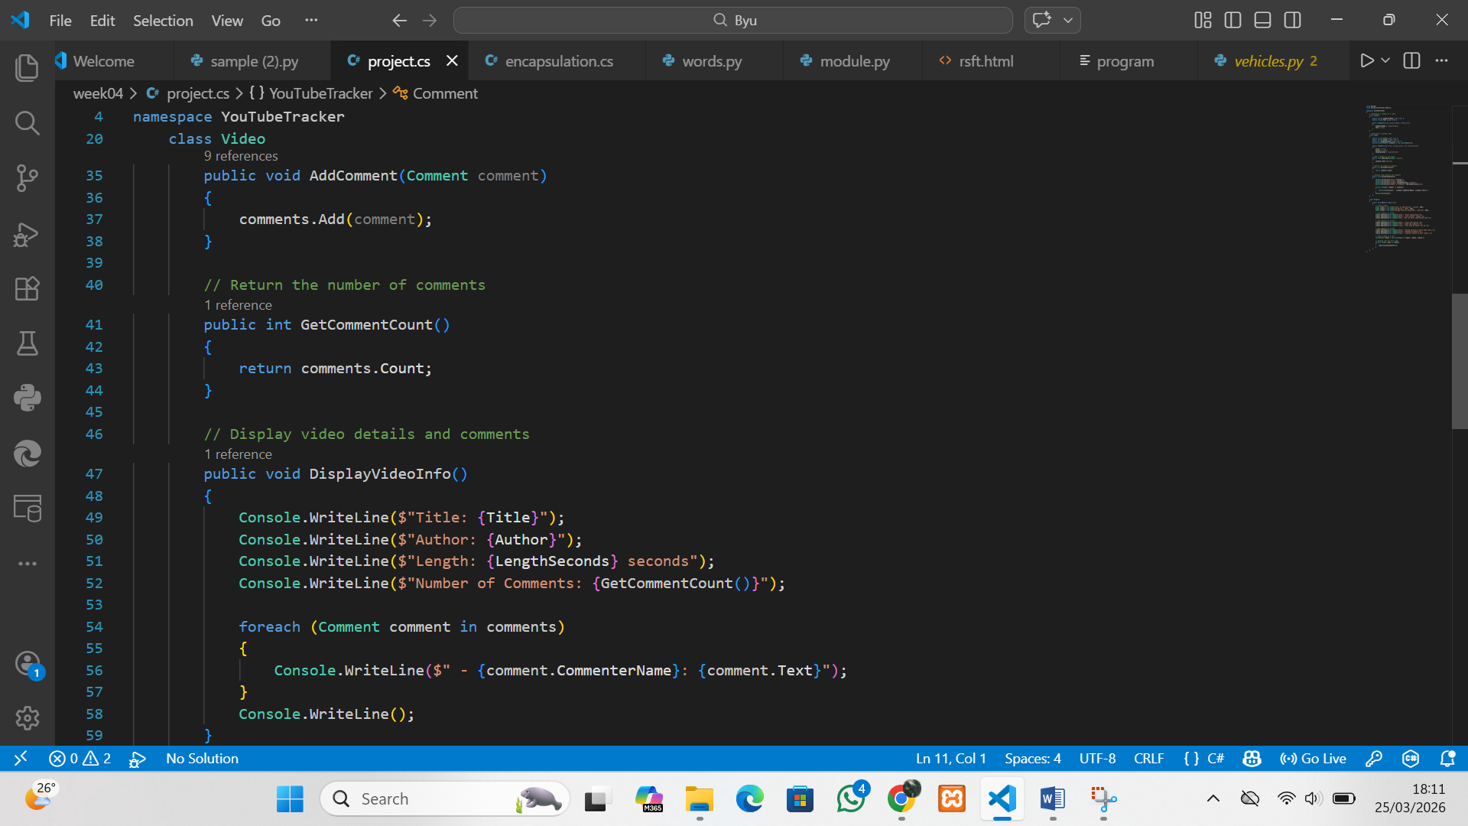
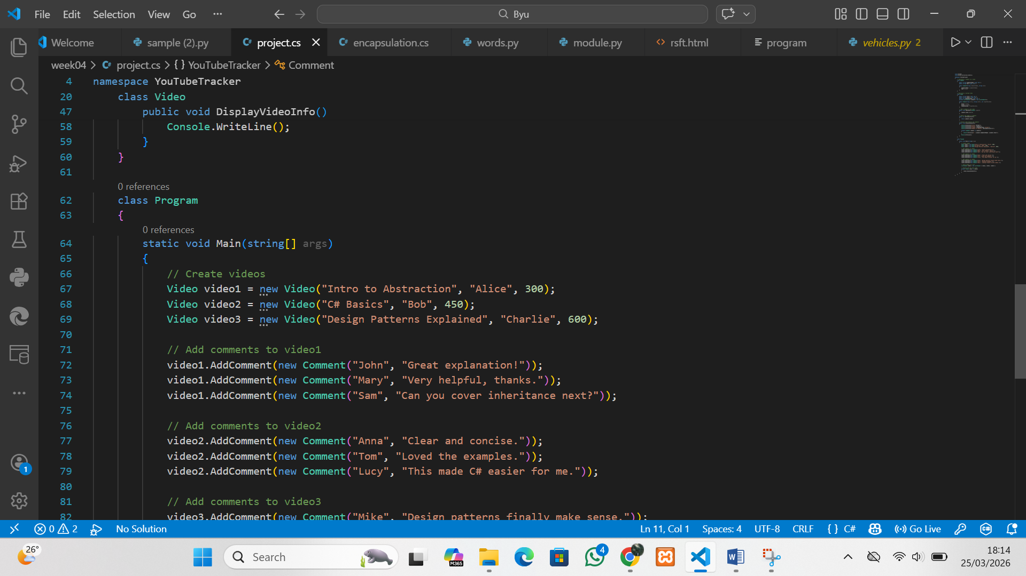
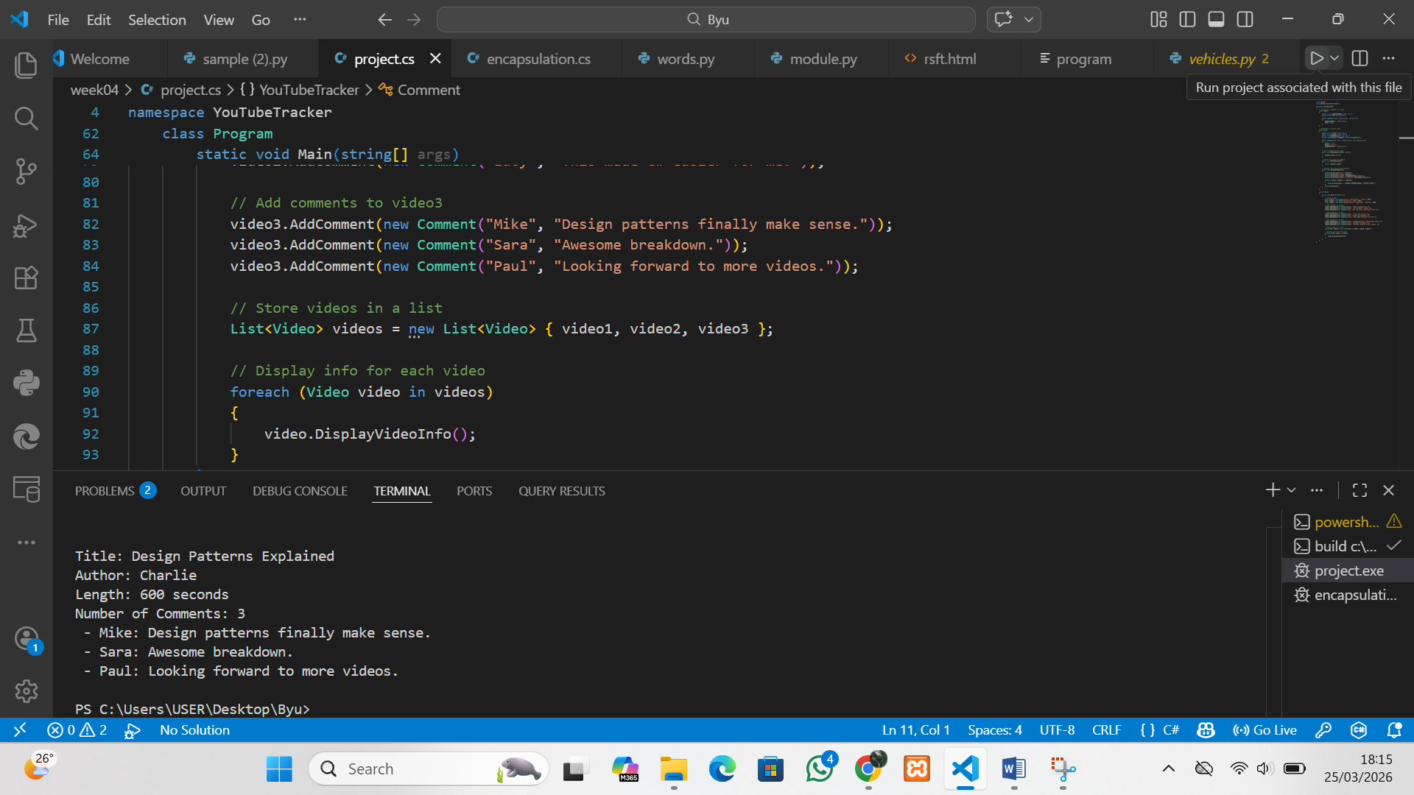

Encapsulation program
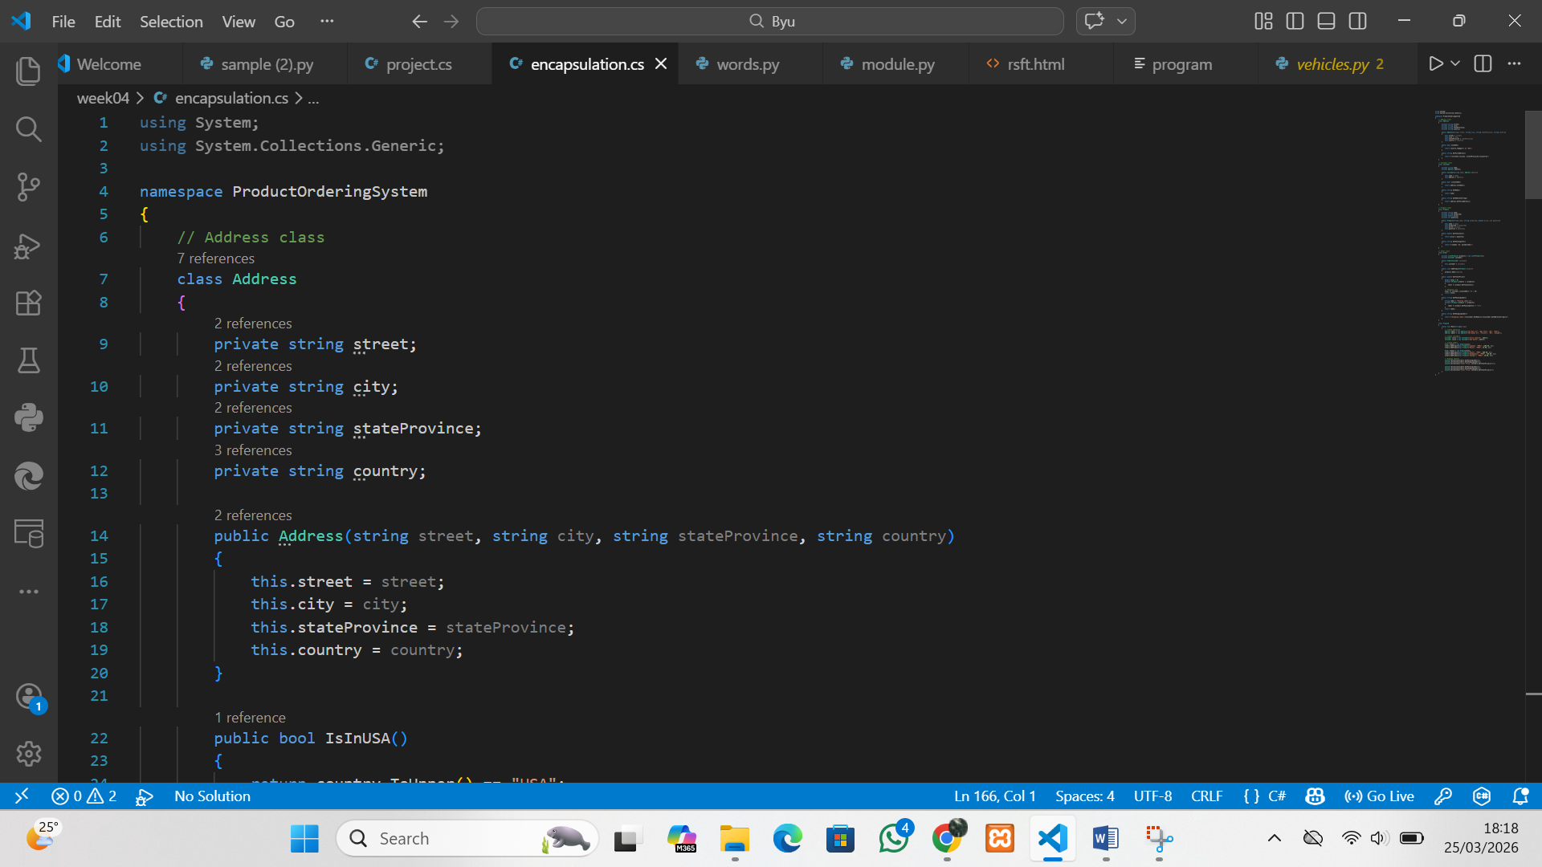
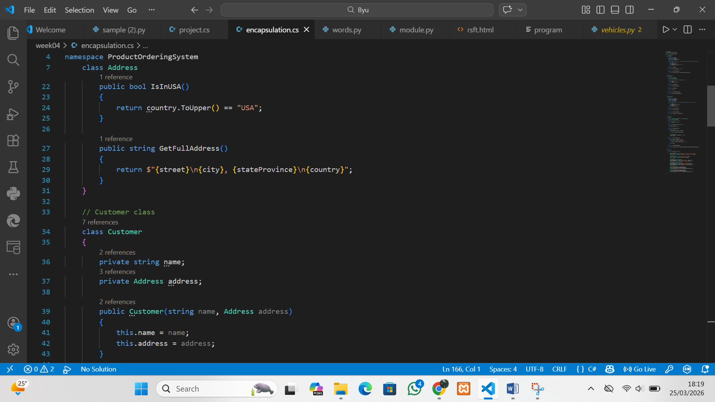
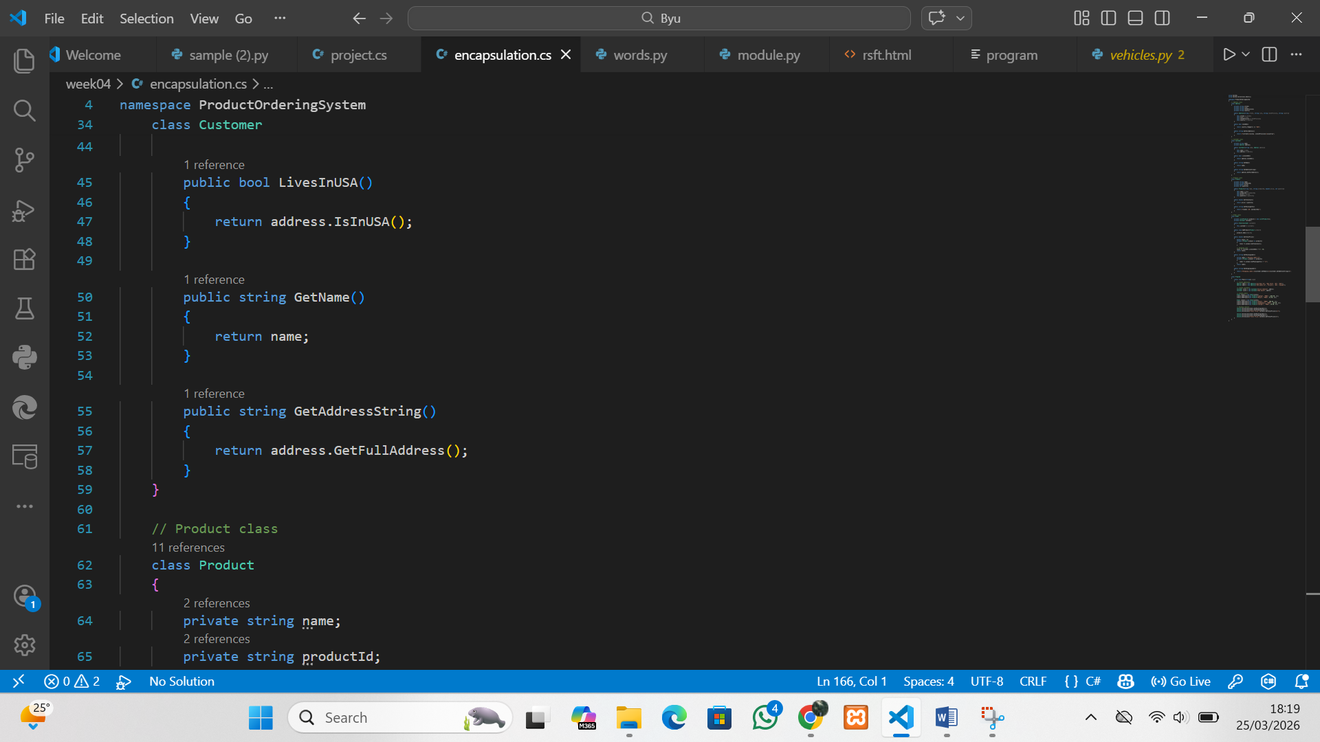
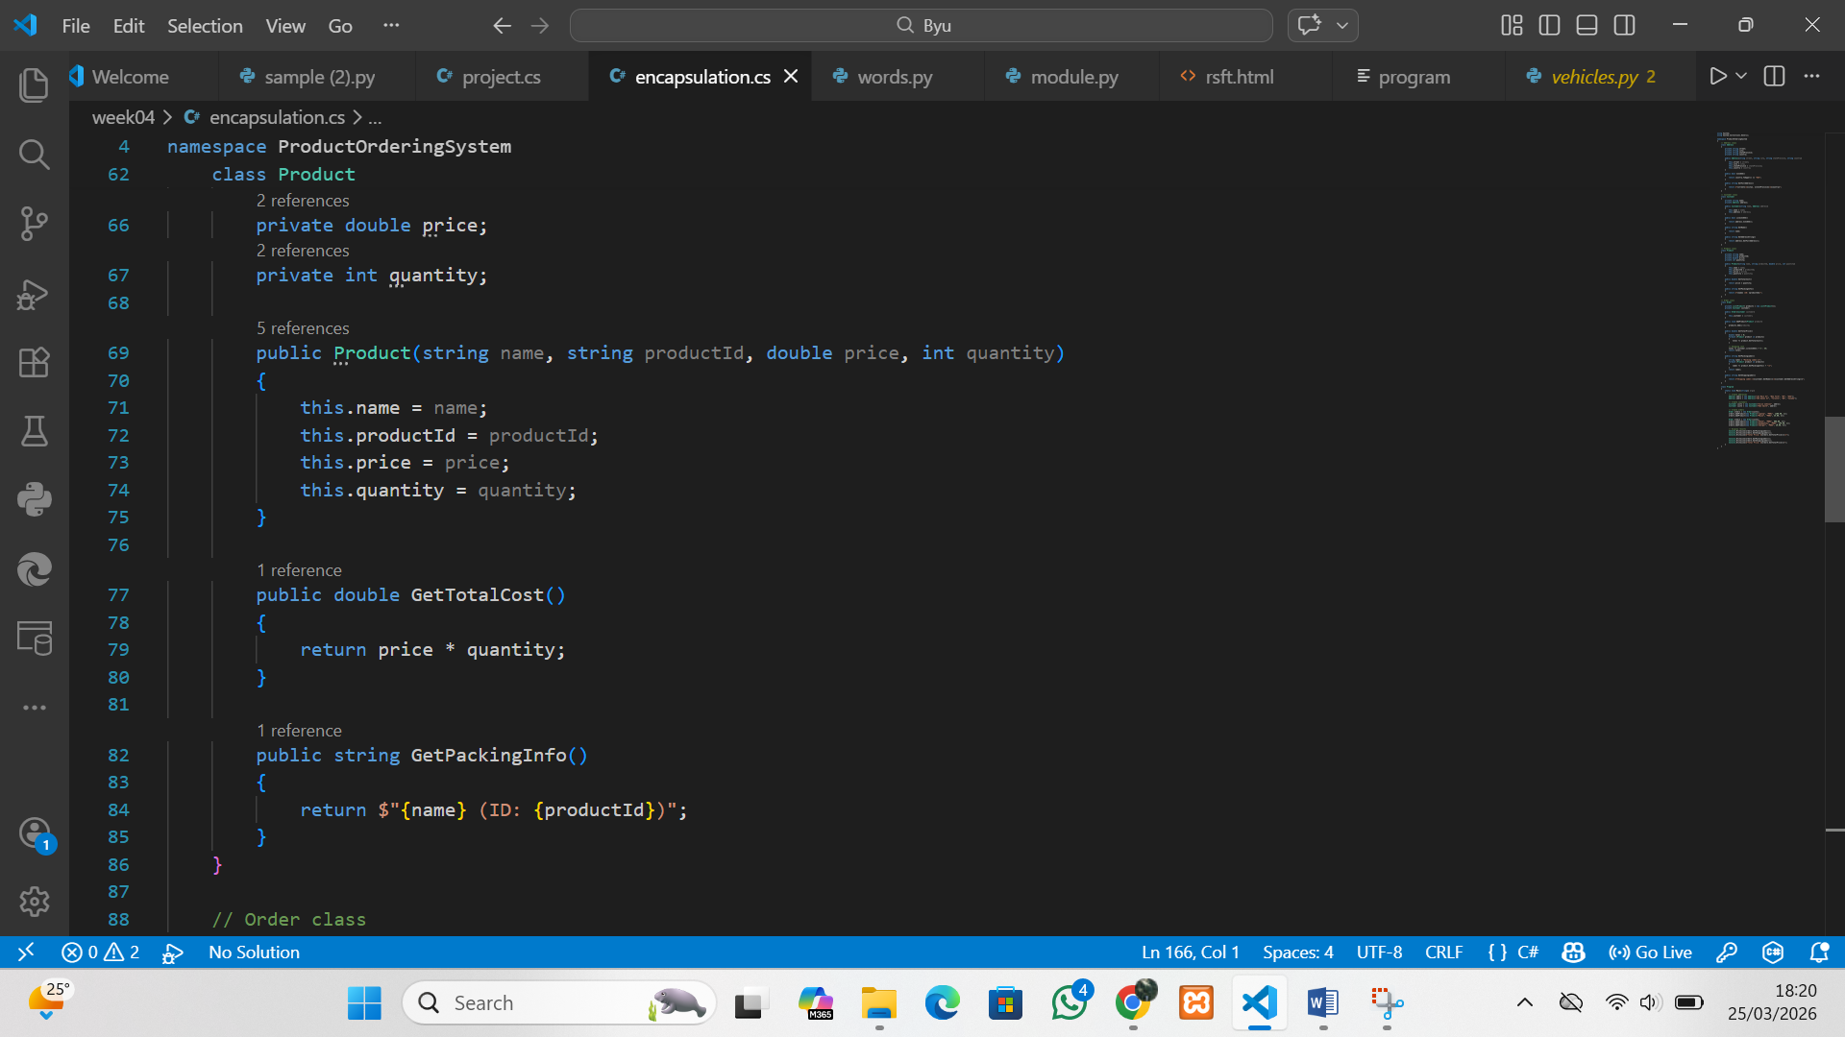
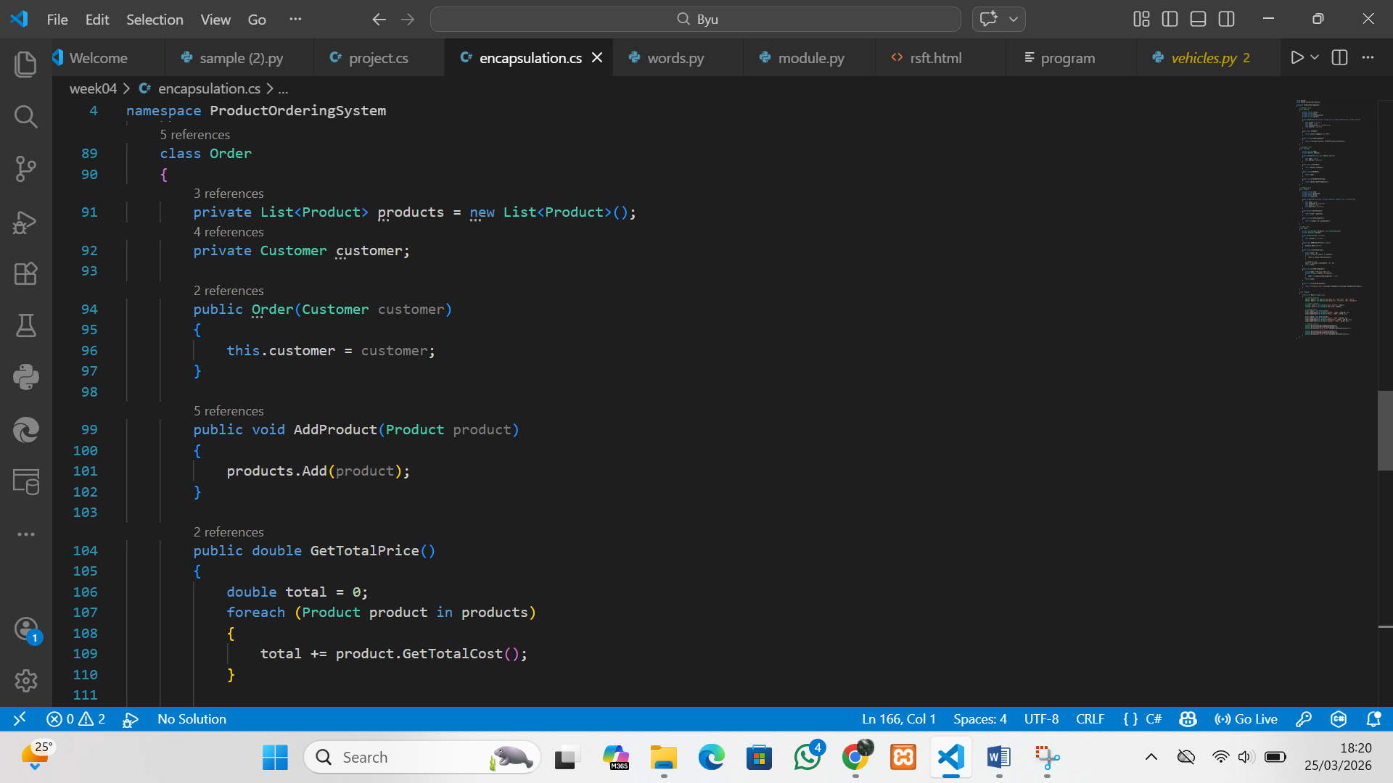
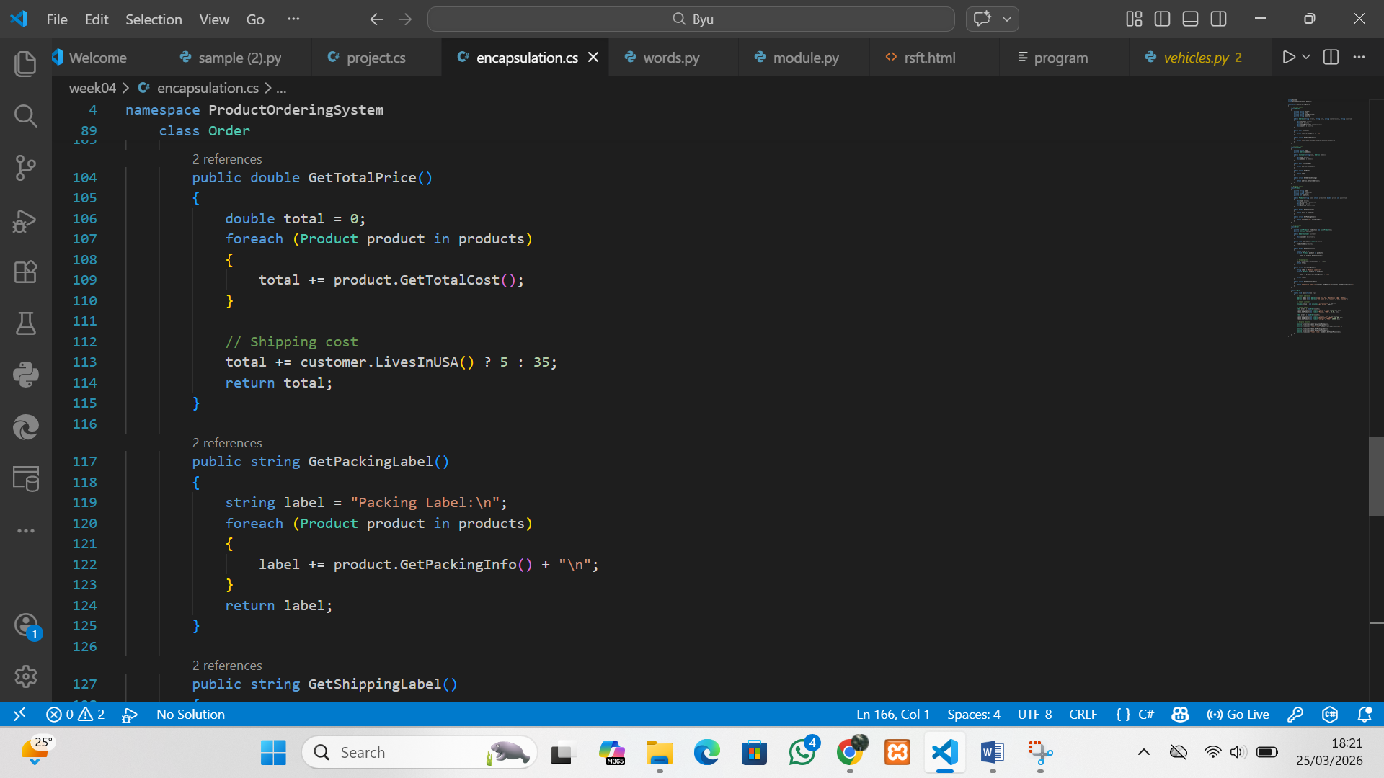
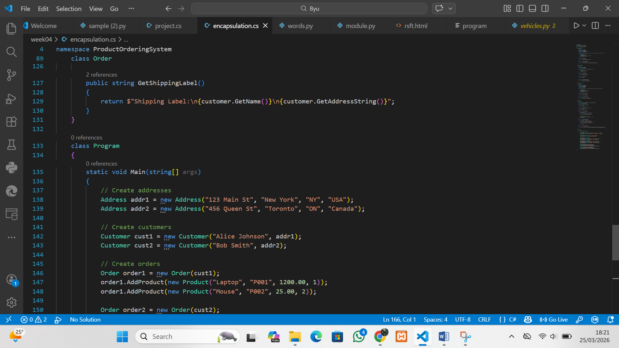
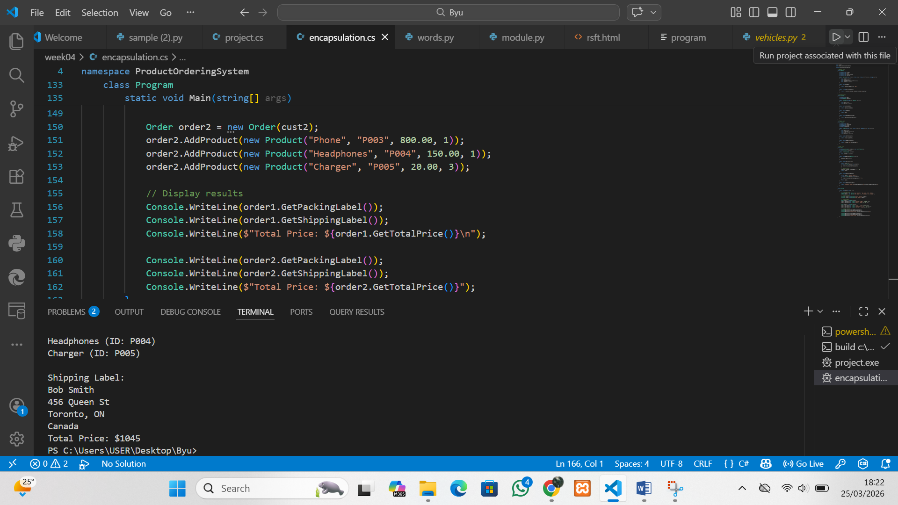Program 1: (Abstraction)

What does the program do?
- Models YouTube videos and their comments.
- Stores video details (title, author, length).
- Stores comments (commenter name and text).
- Displays video information and associated comments.

Candidates for classes
- Video
- Comment

Responsibilities of each class
- Video
  - Track title, author, and length (seconds).
  - Maintain a list of comments.
  - Provide method to count comments.
  - Display video information and comments.
- Comment
  - Track commenter’s name.
  - Track comment text.

Program 2: (Encapsulation)

What does the program do?
- Models an online ordering system.
- Stores product details (name, ID, price, quantity).
- Stores customer details and address.
- Calculates total order cost including shipping.
- Produces packing labels and shipping labels.

Candidates for classes
- Product
- Customer
- Address
- Order

Responsibilities of each class
- Product
  - Track product name, ID, price per unit, and quantity.
  - Compute total cost (price × quantity).
  - Provide packing info (name + ID).
- Customer
  - Track customer name and address.
  - Determine if customer lives in the USA (delegates to Address).
  - Provide customer name and address string.
- Address
  - Track street, city, state/province, and country.
  - Determine if address is in the USA.
  - Return full formatted address string.
- Order
  - Maintain list of products and associated customer.
  - Compute total price (sum of product costs + shipping).
  - Generate packing label (list of products).
  - Generate shipping label (customer name + address).

